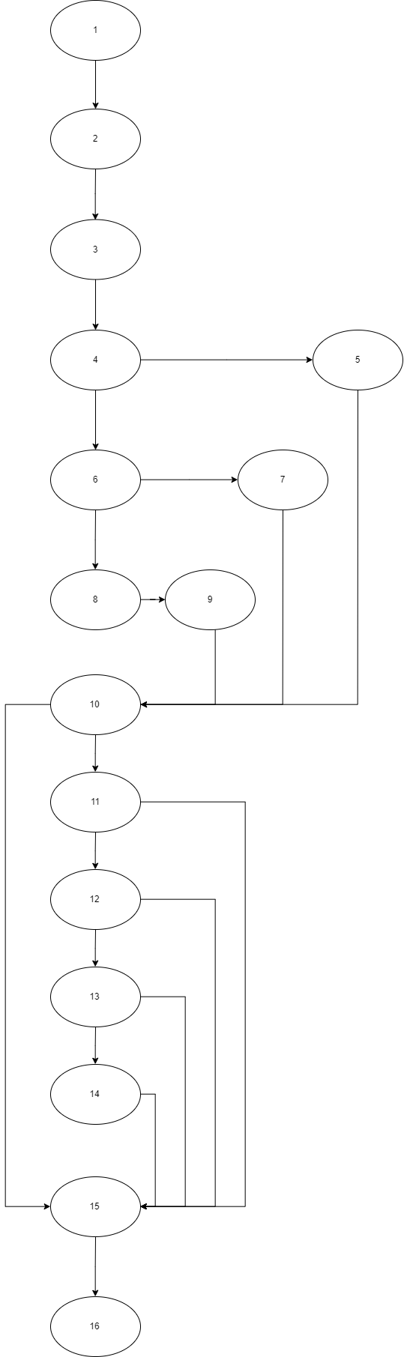

Cyclomatic Complexity

VG = E-N+2  
VG = 21-16+2  
VG = 7

Path

1. 1-2-3-4-5-10-15-16
2. 1-2-3-4-6-7-10-11-15-16
3. 1-2-3-4-8-9-10-11-12-15-16
4. 1-2-3-4-5-10-11-12-13-15-16
5. 1-2-3-4-6-7-10-11-12-13-14-15-16
6. 1-2-3-4-8-10-15-16
7. 1-2-3-4-5-10-11-12-13-14-15-16